**Environment Setup**

**Docker Account Creation**

|  |  |
| --- | --- |
| Team ID | PNT2022TMID36311 |
| Project Name | Nutrition Assistant Application |

**Fadal Razin S**

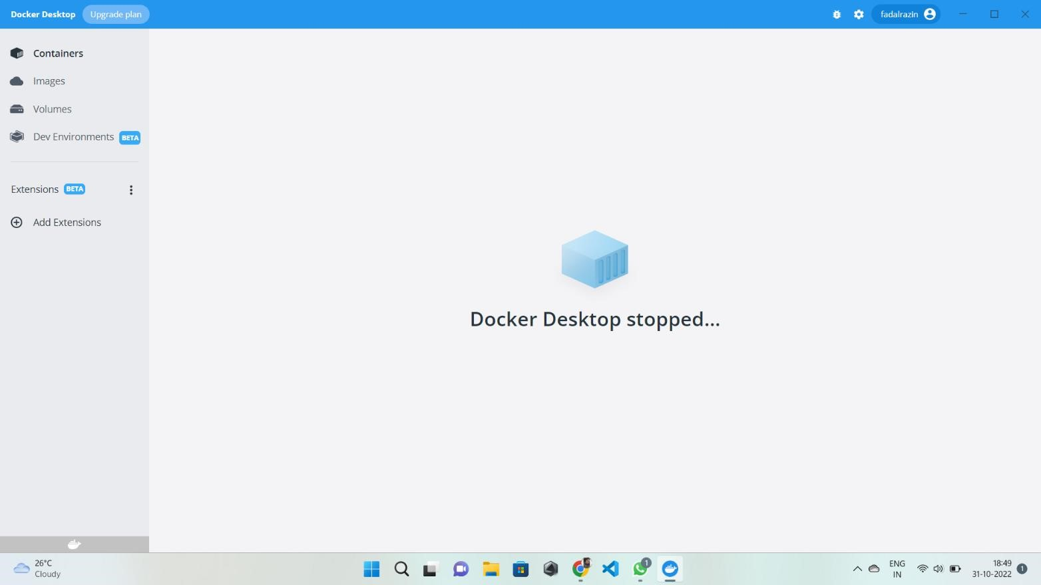

**Hyder Ali**

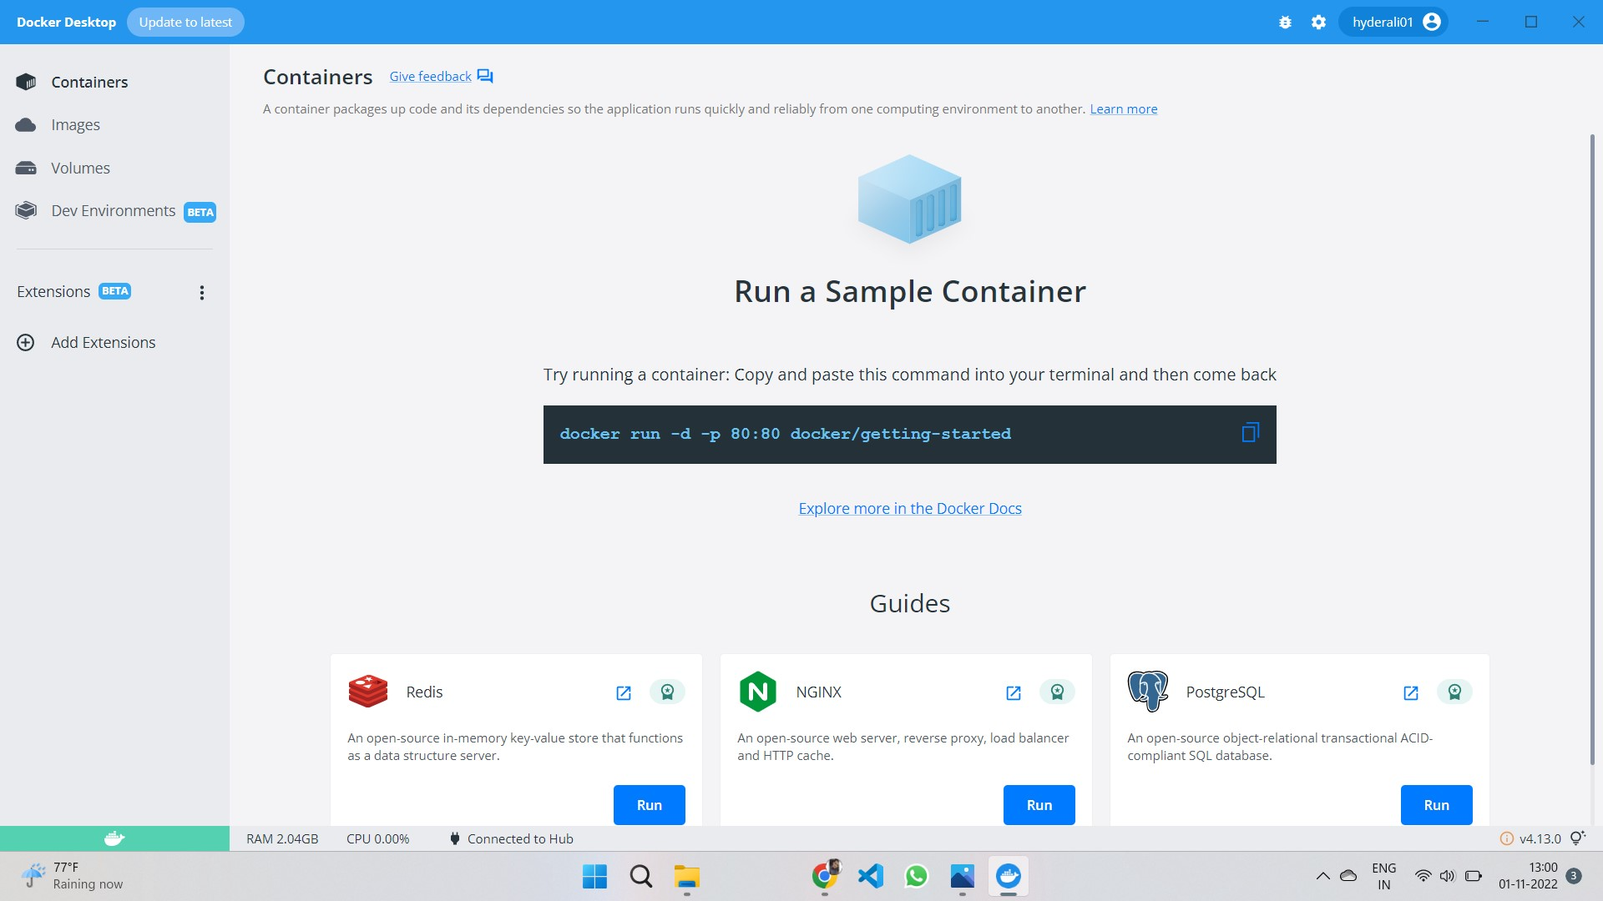

Bazeer Ahamad

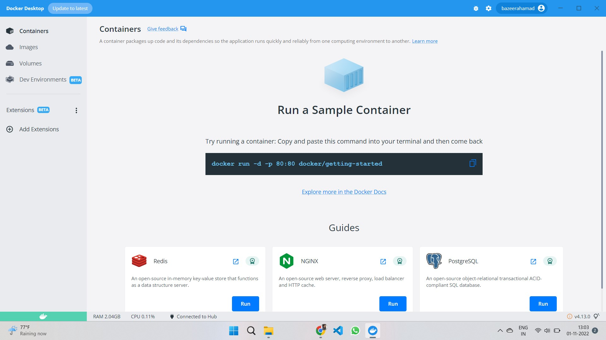

Fauwaaz Ashaal

